Profit trend

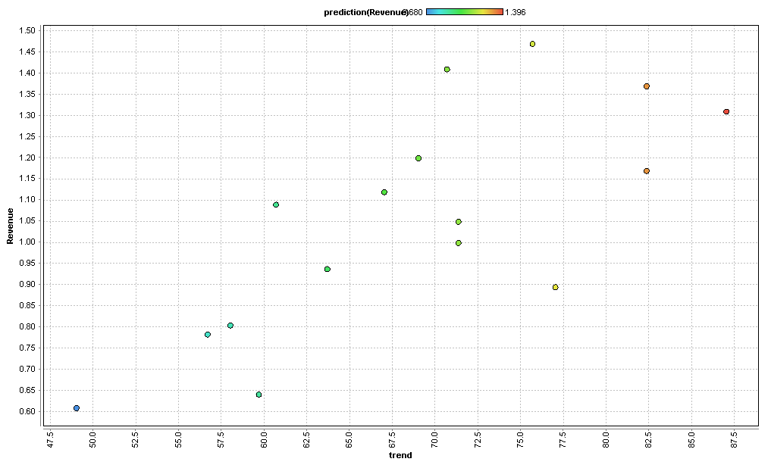

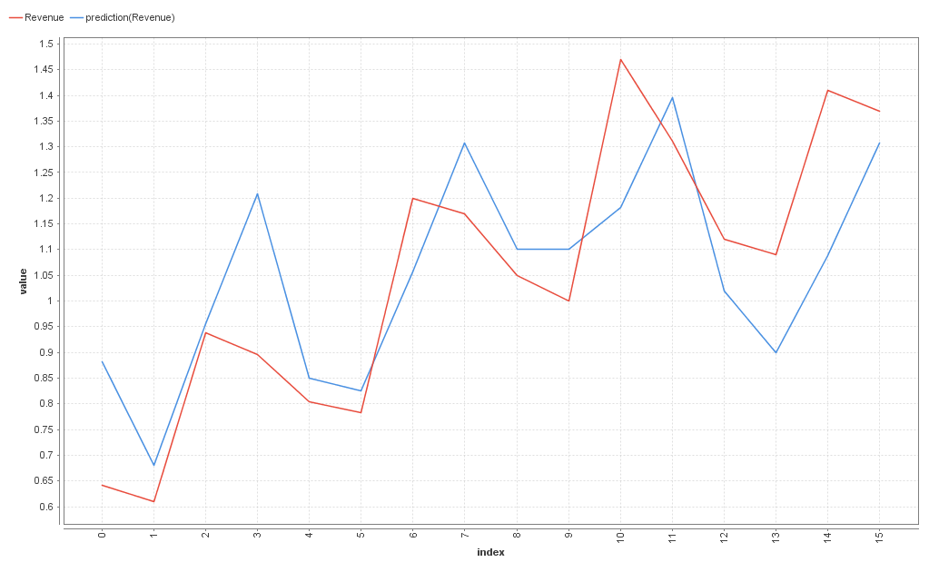

Profit stock

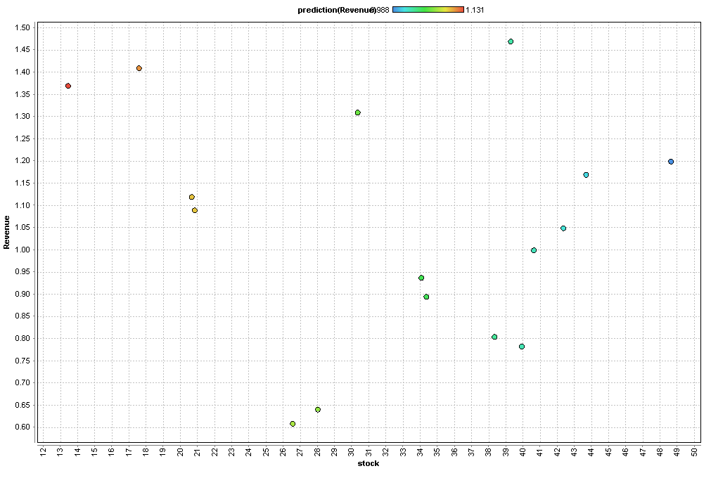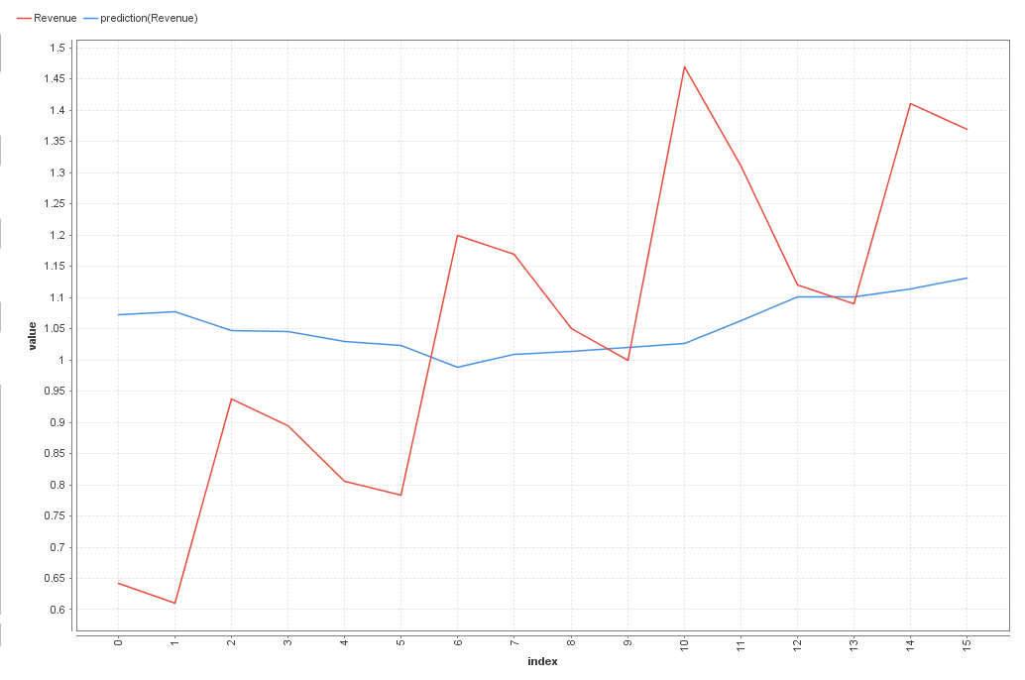

Profit comment

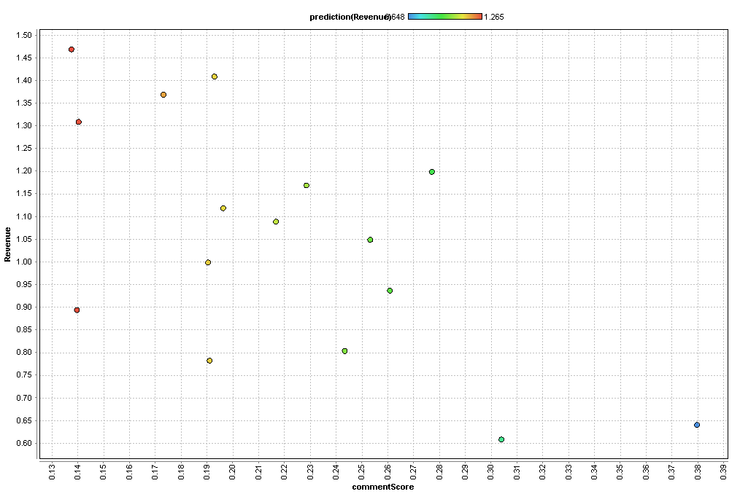

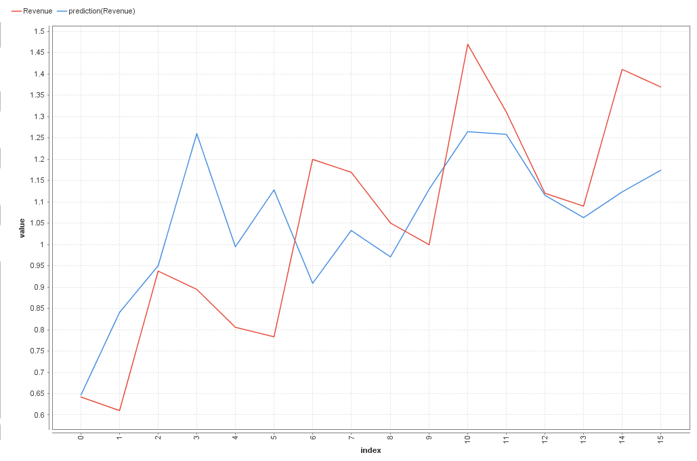

Profit rating

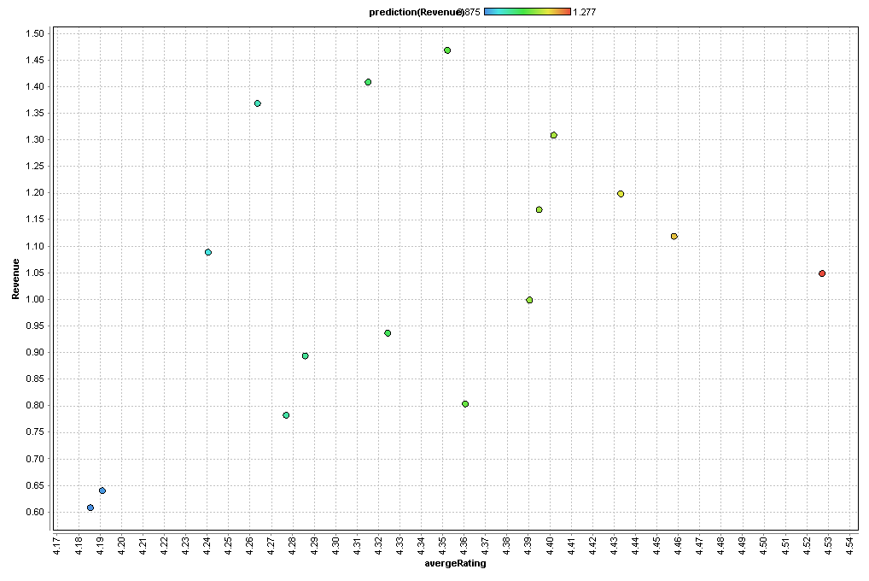

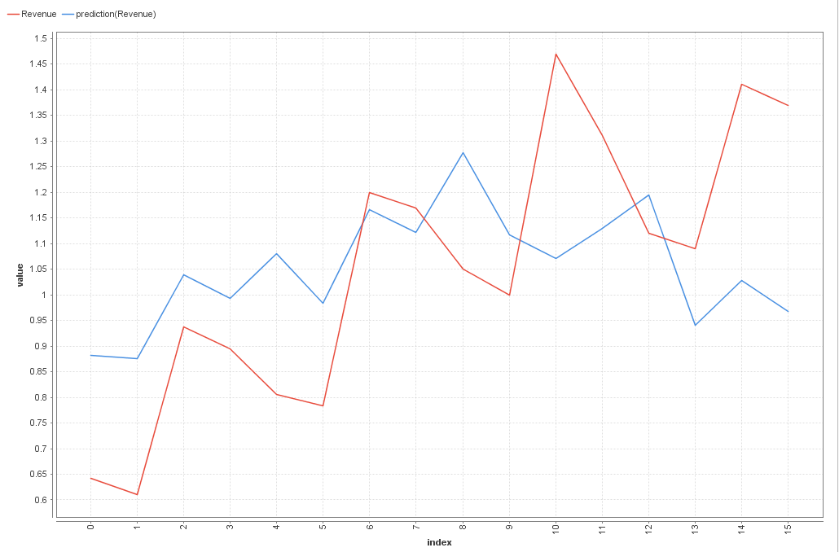

|  |  |  |  |  |
| --- | --- | --- | --- | --- |
| x | y | Coefficiency | P-value | IMG_256 |
| rating | profit | 1.174 | 0.101 | 0.18 |
| comment | profit | -2.55 | 0.009 | 0.396 |
| trend | profit | 0.019 | 0.001 | 0.562 |
| stock | profit | -0.004 | 0.556 | 0.025 |